The dependence gap in Russia-China relations

Tracing where pragmatism ends and geopolitical signalling begins

*By Alessia Caruso and Tim Rühlig*

China does not want to see Russia being defeated on the battlefield in Ukraine. This is what Chinese Foreign Minister Wang Yi told the EU’s top diplomat Kaja Kallas when he visited Brussels in early July. Since the outbreak of the full-scale invasion in February 2022, Beijing has provided economic, military and diplomatic support to the Kremlin, although to different degrees.

China and Russia share deep ideological and geopolitical interests that bind them together. Both governments view US influence and the spread of liberal democracy as direct challenges to their political models and regional if not global ambitions. Their partnership is therefore not just pragmatic, but also strategic: by aligning with Moscow, Beijing reinforces a broader effort to reshape the international order in ways that curb Western dominance. These converging interests explain why China has been willing to extend significant support to the Kremlin, even as it carefully manages the risks involved.

As demonstrated throughout the remainder of this data story, China’s support is not limitless. Beijing has avoided paying a high economic and political price for its help: Moscow has become progressively more dependent. In turn, China has leveraged the asymmetry, by using Russia as a market to absorb its exports. How has Beijing helped Russia and where are the limits of such support? And where does it leave Europe’s leverage to ‘unpower Russia’ – as discussed in a recently published EUISS *Chaillot Paper*?

The following 14 graphs provide the answer. To dive deeper into this subject, consult *Chaillot Paper* No.186, ‘Unpowering Russia’.

# Chapter 1: Growing trade

Since Russia’s full-scale invasion of Ukraine, China has become economically indispensable to Moscow. This holds for both imports and exports.

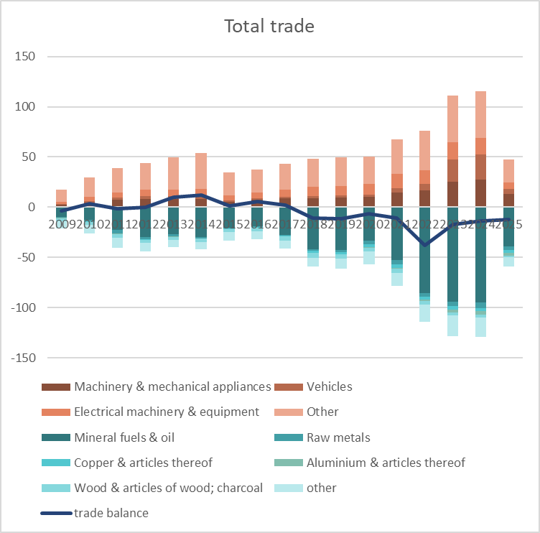  
(This graph will be interactive. [Click here for the full version](https://euisscloud-my.sharepoint.com/:w:/g/personal/alessia_caruso_iss_europa_eu/ESU9gsppwxJAvQ2NHRPgUlMByAarPIXPZfdtyPzcouvt3Q?e=NTZQkQ))

Following Russia’s full-scale invasion of Ukraine, Chinese exports to Russia soared, rising by over 70% between 2021 and 2024 The surge is especially pronounced in strategic sectors such as machinery and electrical equipment. With the exception of wood products, nearly all major trade categories have followed this upward trend. This stands in sharp contrast to China’s behaviour after Russia’s illegal annexation of Crimea in 2014 when trade between China and Russia declined. Granted, both periods are not exactly comparable. In 2014, Russia was not subject to harsh sanctions and Moscow’s aggression was not at the scale of 2024. However, the fact that trade declined after 2014 contrasts sharply with the deepening of economic ties after 2022.

In the same period, Russia has served as an important destination for Chinese exports, particularly as European companies exited the market, leaving supply gaps across sectors. The automotive industry is a striking example, with Chinese manufacturers rapidly expanding into the vacuum left by Western firms, as car exports to Russia in 2024 were 971% higher than in 2021.

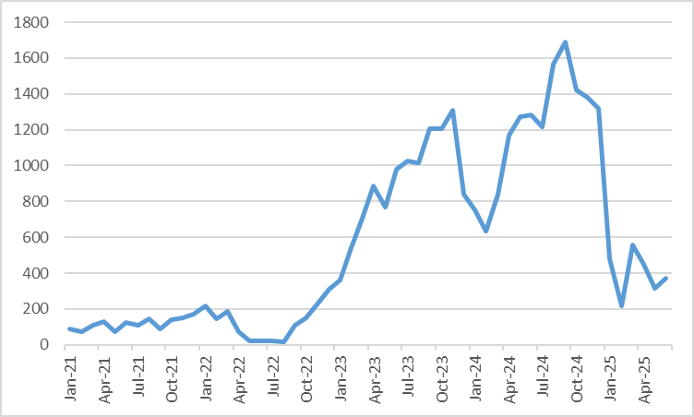

However, this growing reliance is not without frictions. China's overcapacity in sectors like manufacturing is putting downward pressure on Russian industry. In response, Russia has applied *de facto* tariffs on Chinese-manufactured vehicles, a move that led to a marked and sustained decline in Chinese vehicle exports to Russia throughout 2025.



Chinese imports from Russia followed a similar trajectory, rising by 13% after the full-scale invasion of Ukraine in 2022. Since 2017, China has consistently imported more from Russia than it has exported, making Russia one of the few countries to maintain a positive trade balance with Beijing. Yet this surplus is narrowly based: a single category – mineral fuels – accounted for 38% of total trade in 2024 and 73% of all bilateral commerce.

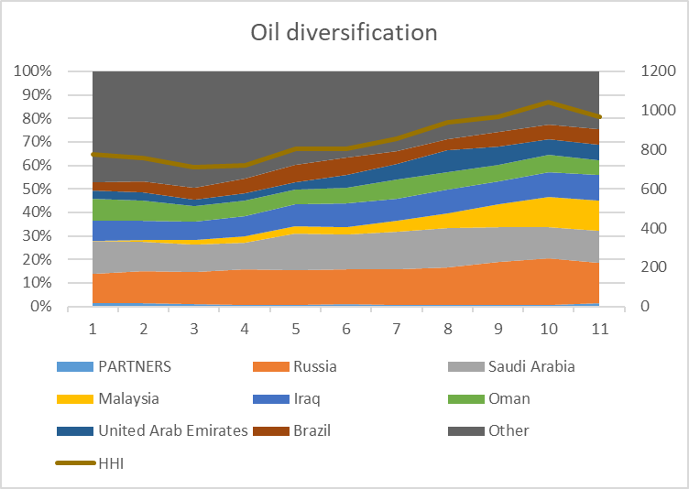

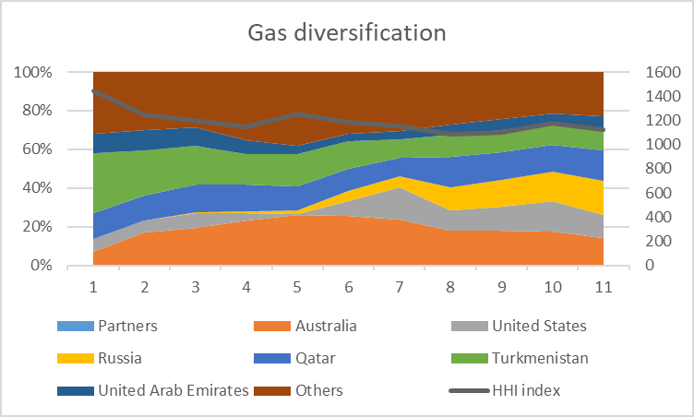

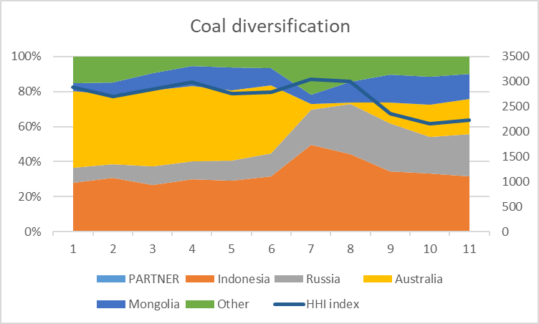

(This is an interactive graph. [Click here to see the full version](https://euisscloud-my.sharepoint.com/:w:/g/personal/alessia_caruso_iss_europa_eu/EYmdEnB4AJtJpjHQ0bmaWEAB9cuzF1LTmvMCeDgmKWwZ1A?e=AegDxQ))

China’s growing mineral fuel imports have centred primarily on oil, with Russia’s share rising steadily over the past decade. By 2024, Russia accounted for 20% of China’s oil imports – its highest level of reliance on any Russian commodity. The diversification index (HHI) also rose over the past year, indicating increased exposure. Still, China maintains a medium-high level of diversification, suggesting that its oil trade with Russia does not yet create significant dependency. Nonetheless, Beijing is likely to continue its decade-old strategy of diversifying its energy sources.

Unlike oil, which is relatively easy to transport, gas largely relies on pipelines, helping to explain why China’s energy imports from Russia are primarily focused on oil. But there is more to China’s trade strategy than mere practicality: for years, Beijing hesitated to agree to building a new gas pipeline, the Power of Siberia 2. Only recently, on the sidelines of the Shanghai Cooperation Organisation summit in Tianjin, Russia and China concluded a memorandum of understanding. Although the deal marks progress for the Kremlin, it remains unfinished. A clear timeline has yet to be set, and no final pricing agreement is in place. While both sides agreed to almost triple gas trade (to 106 billion m3/year), part of this increase could be achieved by expanding the capacity of existing pipelines. This indicates that, for China, trade with Russia serves as a form of political signalling, while still taking its own economic needs into account. Moreover, higher imports of coal and gas from Russia have advanced Beijing’s diversification strategy, with the HHI falling in both cases.

# Chapter 2: Growing asymmetrical dependencies

Despite consistent growth in both imports and exports in recent years, the Russia–China economic relationship remains deeply asymmetrical. Russia is becoming increasingly reliant on China across a widening range of product categories, while Beijing maintains minimal exposure to Russian inputs.

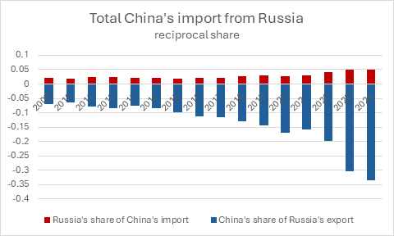

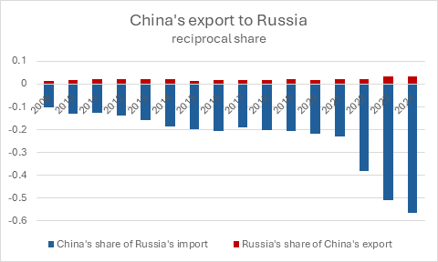

(This is a single graph and it’s interactive. [Click here to see the full version](https://euisscloud-my.sharepoint.com/:w:/g/personal/alessia_caruso_iss_europa_eu/EQYw4MNefotDuiqCLidGT9oBMbs1SlJ9PeOUO0LOeuWE_A?e=RTGZSh))

A comparison of trade shares across major sectors underscores this imbalance. Between 2022 and 2024, Russia’s dependence on Chinese goods surged: the share of Chinese products in Russia’s total imports jumped from 23% in 2021 to 57% in 2024. Over the same period, Russia’s importance as a supplier to China barely altered, with its share of China’s total imports increasing by less than one percentage point.

Russia’s exports to China show a similar picture: even in mineral fuels – Russia’s most strategic export – the asymmetry holds. Russia’s share in China’s fuel imports rose by just 6 percentage points, while China’s role in Russia’s energy exports ballooned from 25% to 38%. In short, Russia is becoming ever more dependent on access to the Chinese market, while China’s exposure to Russian trade remains limited and highly concentrated.

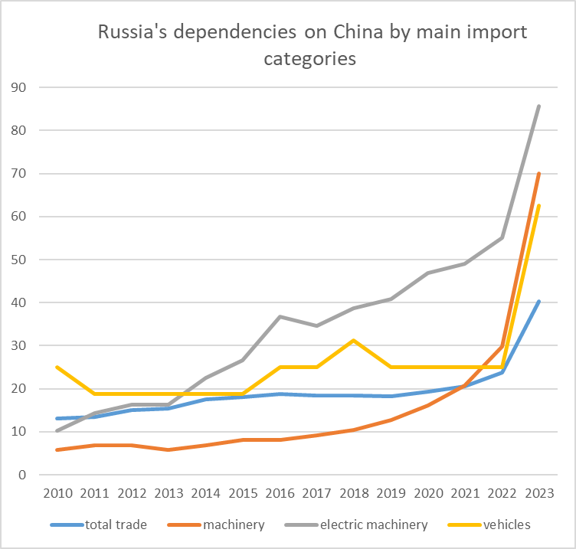

To assess Russia’s dependencies on China further, an analysis of Russian imports across key product categories (at the 4-digit HS level) reveals significant dependencies. A product category is considered ‘dependent’ if more than 30% of imports originate from China and if total imports are at least twice the value of exports – indicating limited domestic production capacity.

This methodology reveals a clear pattern of rising dependencies, particularly in strategic sectors such as machinery and electronic equipment. Applied in reverse, the asymmetry becomes even more apparent: China depends on Russia for less than 0.1% of its product categories.

The result is a pronounced dependency gap that translates into asymmetric strategic flexibility. Beijing retains the hypothetical option to dial back cooperation if the political or economic costs rise. Moscow, by contrast, has no such leverage: its reliance on Chinese goods renders it vulnerable to any shift in Beijing’s calculus. In short, while China can afford to recalibrate, Russia is locked in unless Western sanctions are removed. This imbalance constrains Russia’s room for manoeuvre – and amplifies the secondary effects of any pressure applied to China.

# Chapter 3: Military ties

On the military front, China and Russia maintain long-standing defence ties. Since 2005, the two countries have carried out significant joint military exercises that have expanded in scale, while continuing to trade military equipment.

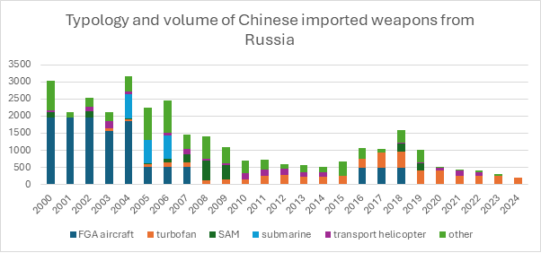

Yet, a clear shift is observable: China's arms imports from Russia are declining. The full-scale invasion has not reversed this trend.

But China’s reliance on Russian weapons is declining not only in volume but also in technological sophistication. In recent years, approximately 80% of China’s military imports from Russia have consisted of turbofan engines – a modern variant of the jet engine produced by only a handful of countries, indicating a niche but persistent dependency. However, even in this area, China is primarily importing less advanced generations of turbofan engines, underscoring the narrowing scope of its technological reliance.

The overall reduction in both quantity and complexity of arms imports – combined with the fact that remaining purchases are limited to areas where China still lacks critical technical know-how – underscores Beijing’s drive for greater self-sufficiency. This trend further reinforces the structural asymmetry in the relationship, with China progressively shedding its reliance on Russian military inputs.

# Chapter 4: Dual-use goods

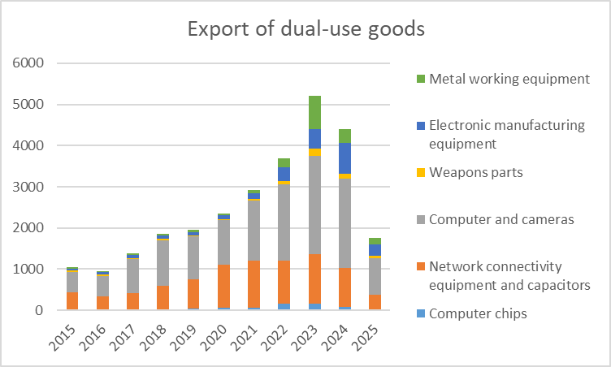

Dual-use goods — civilian items with potential military applications, such as precision machinery, electronics, and navigation equipment — have become a central channel of China’s indirect military support to Russia.

Since the start of the full-scale war in 2022, Chinese exports of these goods to Russia have surged, exceeding USD 5 billion in 2023, with growth concentrated in computers and electronic manufacturing equipment. These flows have helped sustain Russia’s war effort while deepening Moscow’s reliance on Beijing.

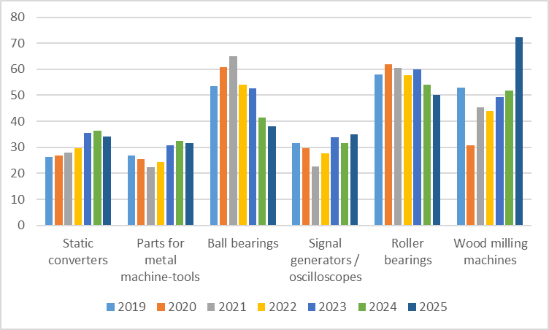

Title: EU share of selected dual-use goods

China is far from being self-sufficient in many of these strategic goods, relying on European exports for a significant share of them.

According to EUISS calculations based on China customs statistics, in 2024, for more than one-third of dual-use product categories, the EU accounted for at least 30 % of China’s imports — worth over USD 57 billion.

For certain items, such as radionavigation systems and telescopic sights, over half of China’s imports originate from the EU. This creates a structural dependency: Beijing’s capacity to export such goods — including to Russia — partly depends on uninterrupted EU supply.

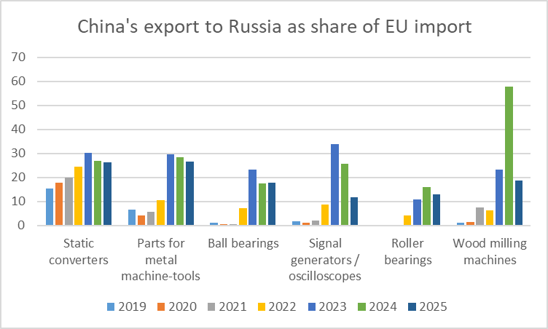

Another indicator that a sizeable portion of China’s dual-use exports to Russia may be transhipments of European goods is the share of export volume to Russia relative to China’s imports of the same products from the EU. Where China relies extensively on EU supply for a particular product, there is a real likelihood that a significant portion of those EU-origin items is diverted from China to Russia.

Analysis shows that for several categories, the share of China’s exports to Russia compared to its EU imports shifted sharply after 2022 — in some cases surpassing pre-war patterns by a wide margin. For example, in 2024, exports of wood milling machines to Russia amounted to nearly 60 % of China’s imports of the same category. For the same product, the EU supplied more than half of China’s total imports, implying a clear risk of transhipment to Russia.

This pattern confirms that EU-origin goods entering China can indirectly reach Russia through re-export, especially in high-dependency categories. According to a classified paper from the German Federal Foreign Office seen by German media, the EU Sanctions Envoy David O’Sullivan estimates that China (including Hong Kong) accounts for around 80% of the circumvention of EU export controls of dual-use items.

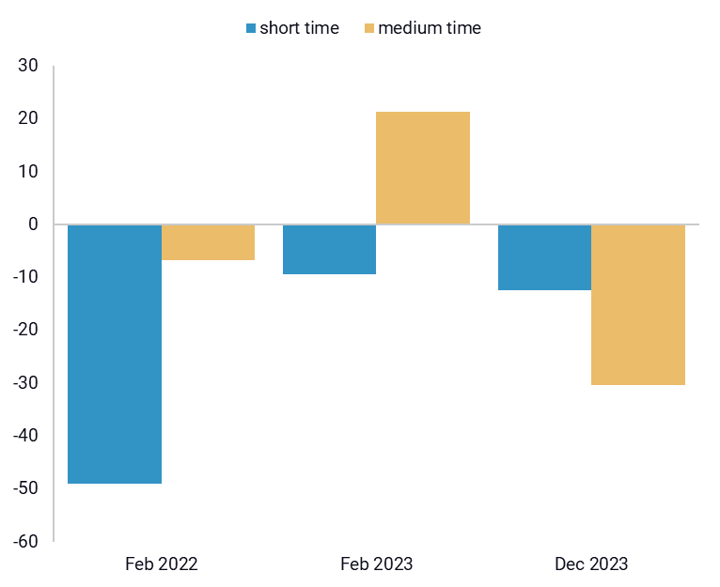

However, also in this case, China's support to Russia is responsive to external pressure. 2024 marked a turning point: for the first time since the full-scale war began, Chinese dual-use exports declined. The drop, sustained in the medium term, followed US secondary sanctions on Chinese financial institutions, highlighting Beijing’s sensitivity to financial pressure and, notably, its willingness to recalibrate when external costs rise.

These dynamics carry clear strategic implications for the EU. In key dual-use categories, Brussels holds significant leverage over Beijing: restrictions on EU exports would compel China to prioritise its own domestic needs, indirectly limiting Russia’s access to critical goods. Evidence from US measures issued in December 2023, demonstrates that targeted, well-calibrated sanctions can alter Chinese export behaviour, even in sectors with direct military relevance. A more coordinated EU approach – using China’s dependencies to apply pressure through precisely targeted export controls and secondary sanctions – could significantly disrupt Moscow’s access to these critical dual-use goods.

European sanctions and export controls have faced implementation challenges: a more coordinated approach, particularly one leveraging Chinese dependencies through targeted secondary sanctions, could prove significantly more effective. Evidence suggests that Beijing is responsive to external economic pressures. It remains to be seen whether and how China would adjust its support for the Kremlin if well-calibrated measures were to target Chinese economic interests. Clearly, China’s support for Russia is mainly driven by political and geopolitical considerations. But the data indicates that despite such political interests Beijing remains responsive to sanctions when they affect its economic interests.

# Chapter 4: Diplomatic alignment

China and Russia are often believed to maintain a shared narrative. Indeed, both promote a vision of a multipolar order in opposition to the Western-led system. However, this rhetorical alignment masks a less consistent reality in diplomatic practice, particularly within international institutions like the United Nations.

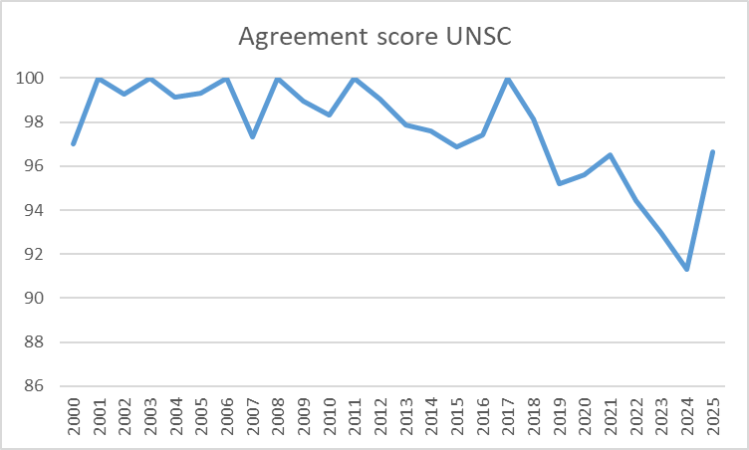

In the UN Security Council, both traditionally align quite well. Since 2021, however, their voting patterns show growing divergence. China has often displayed greater flexibility. The war in Ukraine has not reversed this trend.

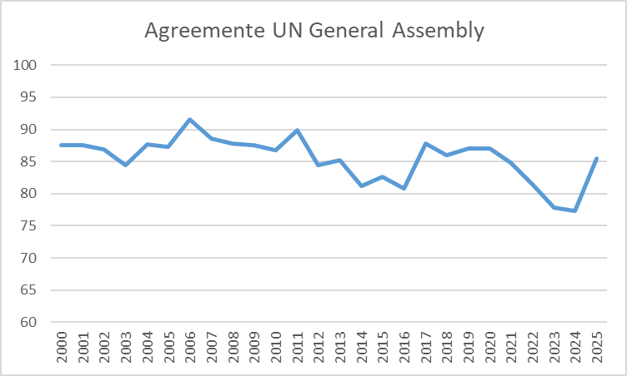

The alignment in the United Nations General Assembly has always been lower, but a similar trend is visible.

Unlike in trade patterns, both instances of Russian aggression against Ukraine in 2014 (Crimea, Donbass) and 2022 (the full-scale invasion) were followed by a decline in the diplomatic alignment of China and Russia. This indicates the limits of Chinese support and a transactional element in Beijing’s policy. Every dimension of its relationship with Russia is calibrated to maximise strategic and economic gains. In the economic sphere, the war in Ukraine offers China clear advantages. At the UN, however, Beijing seems to be more careful and concerned with projecting an image of itself as a responsible global actor, making full alignment with Russia more difficult.

# Conclusions

The China–Russia relationship is solid but not immutable. China has become Russia’s primary economic lifeline. At the same time, China’s dependency on Russia has not increased, thus shaping a highly asymmetrical dynamic. China and Russia are linked by deep ideological and geopolitical interests. Both governments regard US influence and the global spread of liberal democracy as direct challenges to their political models and regional objectives. Their partnership is therefore more than pragmatic; it is strategic. Beijing’s alignment with Moscow advances a broader project to revise the international order and reduce Western pre-eminence. These convergent interests account for China’s willingness to extend significant support to the Kremlin.

Crucially, ideological alignment does not guarantee parallel economic interests. Amid a more competitive environment, political signalling and diplomatic alignment retain strategic value for both; however, economic pressures persist and are addressed in ways that minimise disruption to their public alignment. Our data shows that Beijing does react to external pressure. Its main motivation may be geopolitical, but – as we demonstrate above – it limits its support if this comes with significant economic cost. This sensitivity is often underestimated: the drop in dual-use exports after secondary sanctions, Russia’s retaliatory tariffs on Chinese vehicles, or the slowing alignment at the UN indicate the limits of a friendship that both sides have described as ‘unlimited’. These are not anomalies; they are signs of a relationship that is responsive to pressure and shaped by asymmetries.

This is not to deny the close partnership: China fuels Russia’s war effort, but it does so when the price is low and the payoff high. The EU, as a major trading partner, has tools to raise that price, including by constraining the supply of dual-use items via secondary measures. To this day, the EU has not fully leveraged this potential. It remains to be seen whether Beijing would prioritise its political interest over the economic cost of more severe sanctions; however, the evidence since 2022 indicates that pressure has already curbed elements of China’s support. The rational objective for Europe is not to ‘split’ Beijing and Moscow – their security and diplomatic ties are too binding – but to force a shift in their economic relationship by imposing costs on China. With that purpose in mind, the observable metrics for the EU should be on trade and financial flows, such as export of dual-use goods and critical items, rather than the cadence of high-level statements.

This analysis highlights three core takeaways:

1. The China–Russia relationship is strategic, but responsive – its strength should not be mistaken for inevitability. Despite talk of an ‘unlimited friendship’ as outlined in 2022, China’s behaviour in the partnership is not purely driven by ideological considerations but has pragmatic elements. It remains sensitive to shifts in external pressure.
2. Their relationship is becoming increasingly asymmetrical – Russia is growing more dependent on China. This imbalance grants Beijing strategic flexibility, while leaving Moscow tethered to Chinese supply lines, even as Beijing is not Russia’s only supplier.
3. The EU holds meaningful leverage that should be explored more, especially in the form of secondary sanctions.

The good news is that Beijing’s behaviour towards the Kremlin depends more on the price we make China pay than we might think. It is unrealistic to assume we could dismantle the China–Russia relationship. China has a strong geopolitical and ideological interest in supporting Russia. But increasing the price for Beijing could make it reduce its support. This, in turn, would have enormous consequences for Moscow, which is increasingly dependent on China.

To dive deeper into this topic, consult also the EUISS’s recently published *Chaillot Paper* ‘Unpowering Russia’.